**CMPT-221L – Software Development II**

**Andrew Tokash**

**Tuesdays 9:30 - 10:45 Room: HC 1021  
 Fridays 9:30- 12:15 Room: HC 0005**

**Syllabus updated – September 13, 2022**

**Introduction / Catalog Course Description**

By now students should some programming background and should have taken Software Development I. The focus of Software Development II is similar but will expand to client/server programming. In this semester we will learn specific coding languages and application software as well as applying these skills to design and code a semester-long project. The course will include specific techniques and advice for coding best practices. And as we learn how to code we’ll also learning how to plan and implement a complex software project!

This course builds on CMPT 220 to continue our students' progress towards true software craftsmanship. Students will study advanced concepts in software design and testing while developing skills including, but not limited to, the areas of advanced server-side programming and data integration. Students will work in teams to deploy a practical system. Prerequisite: CMPT 220

**Faculty Availability**

My Home Page: *https://aptokash.github.io/Home/*

My Office: Hancock 3002

***“Going to office hours is one of the pieces of advice that is most often given, but rarely taken.” - Ellen Anderson***

* I have office hours at least three days each week. Walk-ins welcome, but preference given to scheduled appointments.
  + Visit my home page to see the current schedule
  + To schedule office hour: [*calendly.com/atokash*](http://www.google.com/url?q=http%3A%2F%2Fcalendly.com%2Fatokash&sa=D&sntz=1&usg=AFQjCNEi_Tw-l0_wVOhhsK4Wt8TEGIZXzw)
* I prefer ILearn messages for communications, as it keeps all of a course’s materials and communications in one place. If you email me ([Andrew.Tokash@Marist.edu](mailto:Andrew.Tokash@Marist.edu)) please include the course and section number.
* Please use iLearn forum/discussion for general questions on material, expectations, etc. and for posting interesting topics for class discussion

**Required Text and Personal Laptop for Lab Exercises**

|  |  |  |
| --- | --- | --- |
|  | ⏵“PHP & MySQL in Easy Steps” by Mike McGrath    *Note: Second edition features SQL version 8!*  ⏵“Engineering Software Products” by Ian Sommerville  ⏵Free software: MAMP Web Server, PHP, MYSQL  ⏵Online references: [www.w3schools.com](http://www.w3schools.com)  Refer to my website for links to articles, videos, etc.  https://aptokash.github.io/Home/ |  |

I expect students to read and master the textbook material. This will help you become self-learners, an important skill for your future careers. I also strongly recommend anyone pursuing a career in software to read “The Pragmatic Programmer” (2nd edition) by D. Thomas and A. Hunt.

We will also utilize free AWS servers where we will load our code! This will allow us to create ‘real world’ client/server applications that can be accessed on the internet.

**Course Framework**

This course will progress through semester modules in three concurrent paths. We will learn the theory behind software development (project planning, Agile, testing, technological issues, reviews, etc.). We will work on a team project to develop a client/server application for a business (generate user stories, create requirements, write documentation, etc.). The third path is to implement a solution using HTML, SQL, and PHP.

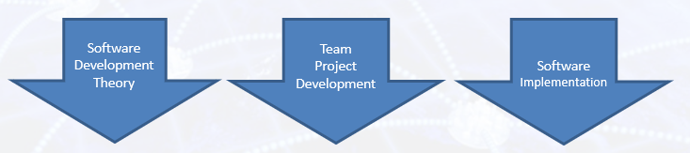

**Weekly Modules, Workload and Expectations**

I expect college level work. All submissions, web code, and presentations should be proofed and professional, and formatted per the guidelines in our Ilearn resources. I also expect students to read the required textbooks.

Each week I will post in the ILearn resources the current module’s resources. A key file is the “READ ME FIRST” file which details due dates, course progress, module contents, student requirements, and other important information. This should be consulted regularly.

Also posted will be: weekly quizzes, assignments, labs and/or projects; PPT slides with supplementary (non-textbook) information; and additional materials or videos.

Assignment, lab and project files must be submitted into Ilearn or on an AWS server. Documents must follow a standard naming convention and have proper page headers. Refer to the file “Submission Guidelines” in the Ilearn Resources section. Unless otherwise specified, submissions should be in PDF format.

**Good note taking** is a key skill for active learning, and reading the textbook is a requirement for the course. For these reasons I will release in Ilearn only the Power Point slides of material that is not from our textbook. (There are copyright restrictions, as well).

There is “Peer Assistance” forum to post issues/questions on any course work.

Note: The guidelines file also lists information on using/citing references and the difference between a 90% A and a 100% A.

No course material – PPT’s, quizzes, videos, etc.– may be reproduced or distributed without my consent.

**Class Attendance Policy**

Students are expected to attend all classes and to actively participate in classroom activities and discussions. (Class attendance helps students learn more, and also prepares you for the workplace where you will also be expected to ‘show up’.) Ensure that you have a study partner to provide class notes in the event of any absences.

Cell phones/laptops/tablets may only be used for note taking and doing labs. I expect all students to be respectful.

In the event of a campus wide ‘pause’ or inclement weather, class periods will be remote via Zoom. When attending via Zoom, students are required to keep their video feeds live, and will be responsible for any class work covered during the normal class time.

During classes, I randomly ask students questions. I hope this breaks up the monotony of a lecture and helps keep students participating. If you choose to not be ‘picked’, for whatever reason, just email stating your preference.

**Educational Approach / Philosophy of Education**

I hope to provide a challenging learning experience that build foundational knowledge and provide students with ‘deep learning’. This will be a collaborative endeavor, and requires self-learning students who care about the material. A truly successful course is not just about getting a grade; it should change, enhance or transform your life.

“*The value of a college education is not the learning of many facts but the training*

*of the mind to think*." - Thomas Edison

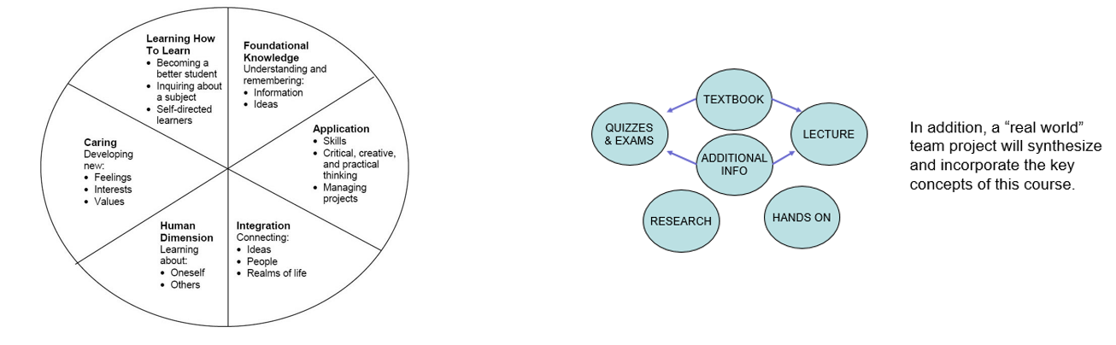

*“Today, companies expect not only technical hard skills, but also so-called professional skills [which] include communication, project management, conflict management, diversity management and teamwork.”* – Marc-Oliver Pahl

**Commenting Code**

As you develop software throughout this course, it is important that the code ‘works’. But more importantly, it is imperative that you understand the *why* and *how* the code works. It is often best to write new code rather than just cut & pasting working code from some other source.

For this reason, I am expecting all code to include well written comments that explain the what your code is doing and *why* the code is required. “Comments should say things about the code that the code cannot say about itself.”

NOTE: If you do copy code from another source, you *must* include a URL reference!

**Computer Science Department Goals**

1. Prepare students for employment or graduate study in a technology field.
2. Provide students with both theoretical knowledge and skills-based proficiencies in the five core technology competencies: programming, hardware, data communications, data management, and systems/software analysis and design.
3. Provide students with fundamental knowledge of business administration and management so that graduates will be able to work effectively within businesses and other organizations.
4. Develop interpersonal skills for working effectively on teams.
5. Develop effective written and oral communication skills.

**Course Objectives[1]**

1. Implement a comprehensive database and web front end using PHP and My SQL [1,2,3]
2. Understand user requirements and reflect requirements in final project. [1,3,4,5]
3. Describe and implement cloud stack resources required for the project (servers, storage, networking, and human skills) and likely technical problems. [1,2]
4. Describe code sustainability and maintenance principles, including proper code documentation, unit test cases, security penetration testing, and sanitizing all inputs. [1,2]
5. Describe and Implement Fundamental Principles used in the project including page redirect, secure sign-on, eye-dropper principle, database search [1,2]
6. Develop and present comprehensive software and project documentation. [4,5]

A detailed list of ‘core competencies’ is provided in the iLearn resources, which details, by weekly module, expected acquired knowledge topics and demonstratable skills.

I hope students will: master the material and its relationship to other courses; understand the personal and social aspects of the subject; and want to learn MORE about writing ‘good’ code and developing software projects.

Note: Due to the pandemic we’re often forced to incorporate online instruction and online team-work. While this has some drawbacks, it also prepares students for the modern workforce, which more and more include remote employees and online team projects.

**Course Evaluation**

Students are assessed through exams, self-assessment quizzes, assignments, presentations and projects. Written projects and presentations will be used to assess their interpersonal, written and oral skills.

10% Weekly Self-Assessment (Open Book) Quizzes

25% Lab and Weekly Assignments

20% Semester Project and Presentations

20% Midterm Exam

25% Final Exam

I generally do NOT accept late submissions, nor do I assign extra credit.

The aggregate grading policy for midterm and final grades will be a slightly modified Marist grading system, and will be displayed in the iLearn gradebook. Please continuously monitor your iLearn grade and contact me for any questions. Do not wait until final weeks to bring up any issues.

|  |  |  |
| --- | --- | --- |
|  | 94 **A** | 90 **A-** |
| 87 **B+** | 83 **B** | 80 **B-** |
| 77 **C+** | 73 **C** | 70 **C-** |
| 65 **D+** | 60 **D** |  |

**All assignments are to be submitted by the due date specified.** Late submissions – if accepted – will have a 20% penalty. NOTE: I generally do not provide extra-credit or make-up assignments.

Make-up opportunities for assignments, assessments, and exams are provided only for verifiable extenuating circumstances cleared through CAAS. Acceptable excuses for late submission of assignments include situations covered in the Student-Athlete Handbook, illness, and serious extenuating circumstances (e.g., death in the family, serious illness).

**Semester Schedule**

Below is the tentative semester schedule. It is a work in progress and will change through the semester. The “READ ME FIRST” file in iLearn will be updated and will reflect the current schedule. I will display it at the start of each class.

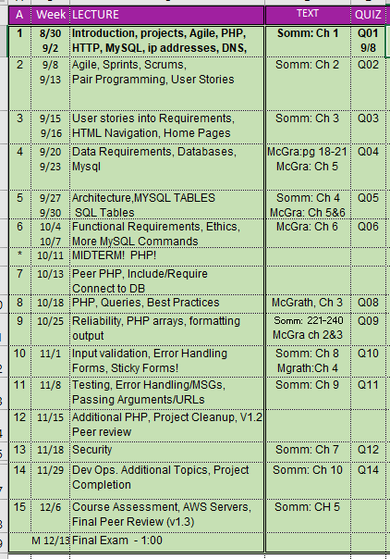

**Learning Disabilities**

Students have all types of learning disabilities. It is your responsibility to notify the professor in the beginning of the semester in order to make sure you are successful within this course! If you’re unsure whether you have a learning disability, make sure you see Special Services within Donnelly as soon as you suspect your disability.

**Academic Honesty**

Faculty will uphold and enforce the general policies of this institution on academic honesty and plagiarism. All examinations, assignments, and projects are subject to the standards of academic honesty as described in the Student Handbook and/or other related publications.

Neither plagiarism not cheating will be tolerated. If you are suspected of cheating, you will be asked to explain the work. If you cannot you will be ejected from the course with a failing grade, in addition to any other forms of recourse available to the instructor as specified by the Student Handbook.

You are encouraged to discuss the course material, concepts, and lessons with other students in the class. However, your labs, exams and discussions must be your own work. If you are caught copying or otherwise submitting material that is not solely your work, you will fail the course and a letter will be sent to the department chair.

Please consult the ACM code of ethics. See [www.acm.org/constitution/code.html](http://www.acm.org/constitution/code.html).

**Diversity and Inclusion**

The college's academic mission is immeasurably enriched by students with diverse experiences. Our finest efforts as intellectual beings heavily rely on the exchange of ideas. Interactions in our classrooms among persons and groups with diverse backgrounds, ideologies, and experiences facilitate these efforts by allowing us all to be more reflective about the varied historical and social contexts in which we work and learn.

In this course, we will challenge each other’s thinking while working collaboratively to ensure that the classroom is a space of safety and bravery. Our classroom offers an environment where individuals of varying opinions, experiences, and backgrounds can freely learn without fear of being silenced.

Aspects of diversity include, but are not limited to, race, ethnicity, color, nationality, sex, gender, gender identity, gender expression, class, sexual orientation, religion, age, ability, and veteran status. Students who would like to be identified in a manner other than what is indicated on the course roster can contact me privately to indicate name, pronoun and any other preferences they may have.

**Title IX Information**

Marist College is committed to providing a safe learning environment for all students. If you or someone you know has experienced sexual harassment, including sexual assault, dating or domestic violence, or stalking, support is available. Please contact the Title IX Office at titleix@marist.edu or (845) 575 - 3799 or visit www.marist.edu/title-ix to file a report. Please be aware that faculty and staff are required to disclose incidents of sexual harassment or other potential violations of the Marist College Discrimination, Harassment, and Sexual Misconduct Policy to the Title IX Office. To speak to a confidential resource who does not have this reporting responsibility, contact Counseling Services at (845) 575 – 3314, Health Services at (845) 575 – 3270, or Campus Ministry at (845) 575 – 3000 (x2275).

**How to Get an “A”**

1. Attend classes. If something is unclear ASK for a better/different explanation.
2. Be an active student. Take notes, listen, speak, ask questions.

Refer to: http://www.dartmouth.edu/~acskills/success/notes.html

1. Do a quick review of chapters BEFORE the class to identify confusing sections.
2. Read the chapter and review each section’s TEST YOUR UNDERSTANDING questions.
3. Do all assignments and submit them on time with proper formatting and citations. Begin assignments early in case you have questions.
4. Do not copy assignments from other students, the Internet or any other source.
5. Take your time when doing the SELF ASSESSMENTS. Review material BEFORE taking the quiz.
6. Study for the exams. Use the Core Competencies as a study guide.
7. Work with other students and take advantage of office hours.
8. Monitor your grades weekly!
9. Use a flashcard app (ex: Quizlet) to utilize flash cards as a study tool.
10. Participate fully in team projects!
11. Use the Marist Writing Center and the other resources.
12. If you have any questions, confusion or issue, address them immediately. Do not wait until the end of the semester to do so.

**Changes to This Syllabus**

08/29/2022 Original syllabus for fall 2022

09/04/2022 Room changed for Fridays 9:30   
09/13/2022 Removed attendance from final grades (due to CoVid)

*End of Document*

1. The reference number in brackets [ ] indicates the department goal that is being met with the fulfillment of the objective.